Short instruction for using GPP codes

As explained in our previous papers (doi:10.3389/fnins.2016.0003; 10.1371/journal.pone.0219281; 10.5220/0010912400003123) instead of plotting only one of two successive RR intervals on each of the two axes, in this analysis we sum “j” previous and “k” following RRIs to construct scatter grams which we named Generalized Poincare Plots (GPP) of the order (j,k). Depending on the order, these scatter grams acquire different properties which can be studied quantitatively, such as Pearson’s coefficient, Guzik’s parameters SD1, SD2, Cup, Cdown etc.
(DOI: 10.1515/BMT.2006.054)

There are two similar but still different analyses: symmetrical (j = k) and asymmetrical one (j ≠ k), with two MATLAB programs “gppsym” and “gppasym” dealing with each of them. Input vectors should contain R peak positions (in seconds) detected in one ECG recording, where name of the variable should match the name of the file. If that is not the case, programs can be easily modified to handle any specific case (e.g. if the variable has a fixed name, independent of the MATLAB file name, etc.). Vectors can be either vertical or horizontal.
In the following text my comments are bolded.

1) Symmetrical analysis

>> gppsym
enter filename with R peak positions (sec):johndoerpo
maximal GPP order:100
plotting of GPP for each order (y/n):y

Here, if you choose “y”, a series of GPPPs will be displayed for each GPP order.

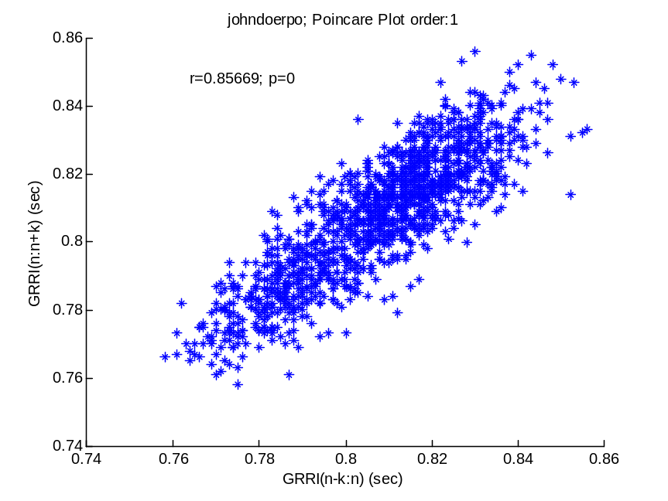

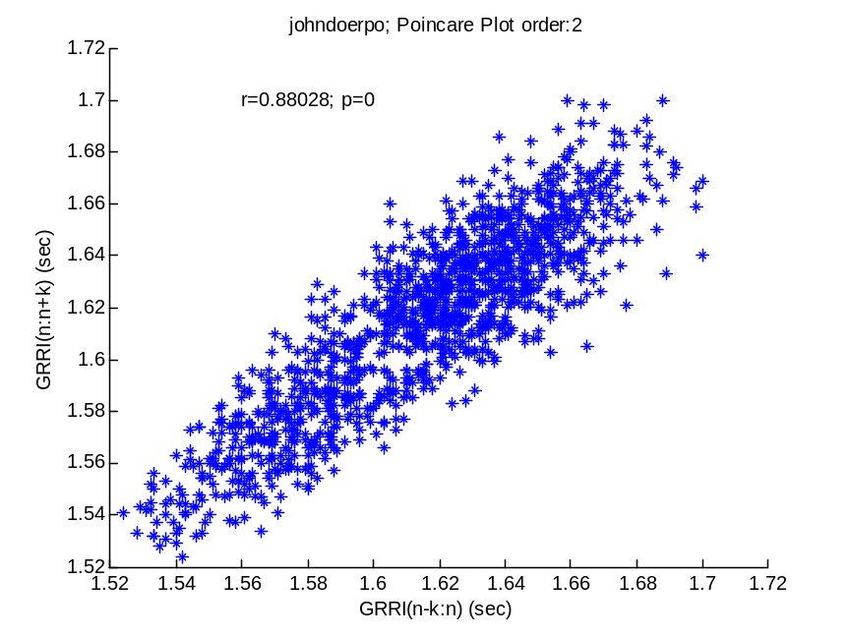

Here you can watch a random-like scatter gram slowly transform into an interesting curved connected graph.

********

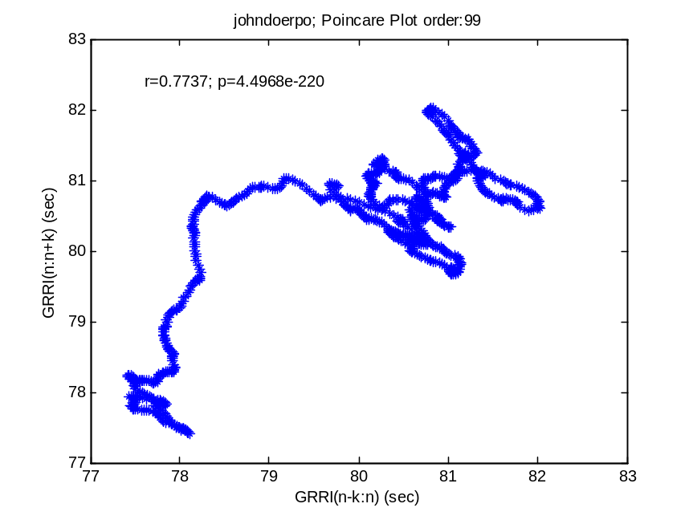

and the final order plot
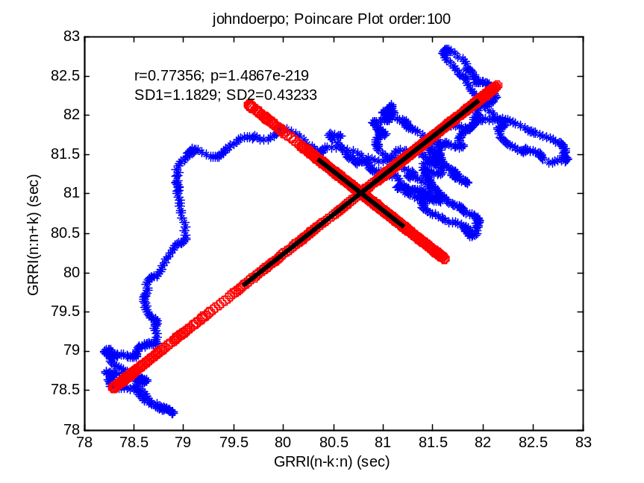
As you can see, the final plot contains point projections on the two diagonals (main and its perpendicular) marked with red circles. Also, two standard deviations are displayed: along and across the main diagonal (SD1, SD2, respectively), both numerically and as thick black lines. However, these parameters do not match exactly Guzik’s variables SD1 and SD2 because he calculated them in relation to the identity line, while ours are computed in relation to the two diagonals drawn through plot’s center (crossing in the two mean values). However, we calculated Cup and Cdown exactly according to Guzik’s formulas.

As well, you can study the dependence of the Pearson’s coefficient of linear correlation on the GPP order.
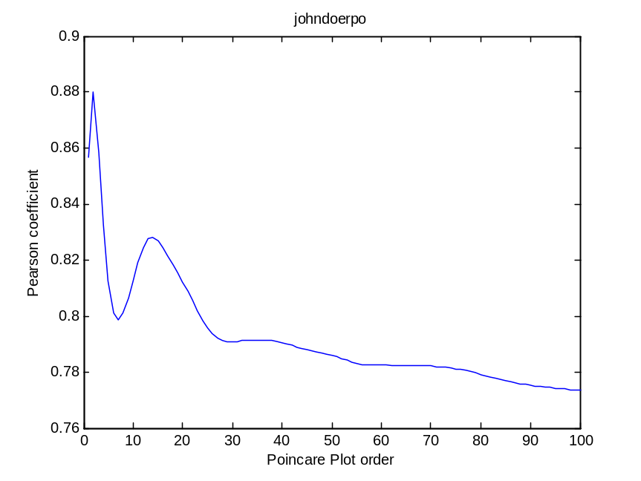
The next plot presents dependence of our (not Guzik’s) version of SD1 and SD2 on the GPP order.

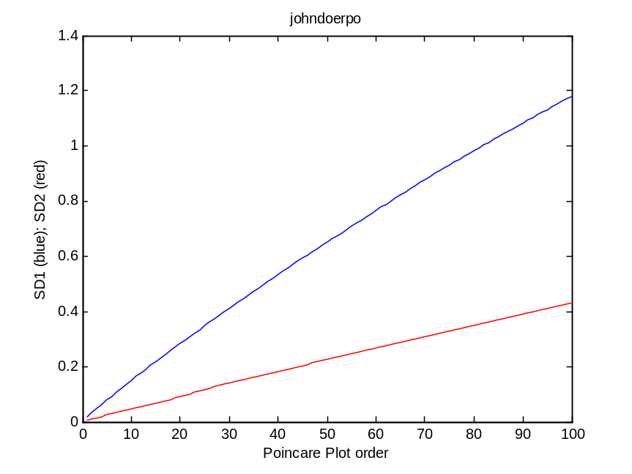

Finally, dependence of Guzik;s parameters Cup and Cdown on the analysis order is displayed in the following plot.

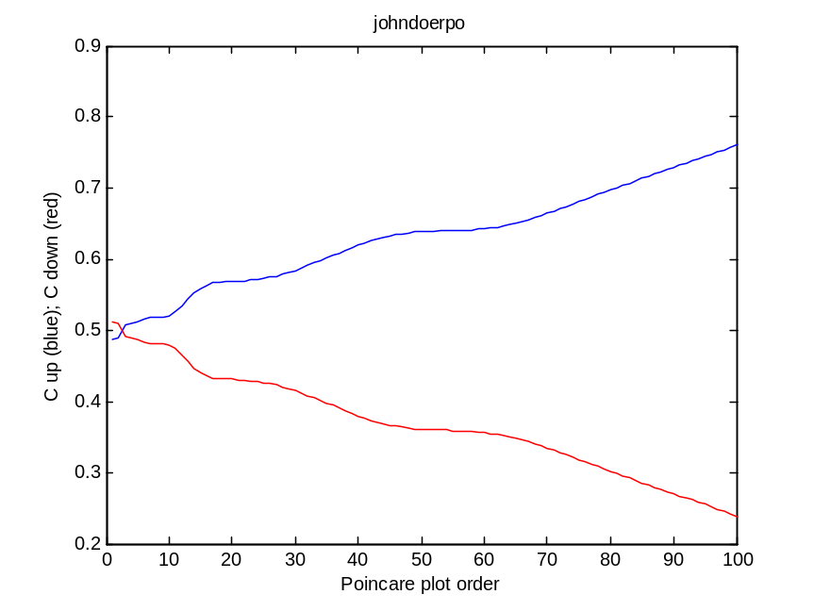

2) Asymmetrical analysis

>> gppasym
enter filename with R peak positions:johndoerpo
maximal GPP order:100
plotting of GPP for some index combinations (y/n):y
enter minimal, step and maximal order for GPP plotting:[1 49 100]

If you answer with “y”, a series of GPP subplots are displayed, their order depending on the values in the square brackets. For this particular combination they will be as follows: j,k = 1,1; 1,50; 1,99; 50,1; 50,50; 50,99; 99,1; 99,50; 99,99.
(50 = 1 + 49; 99 = 1 + 2*49)

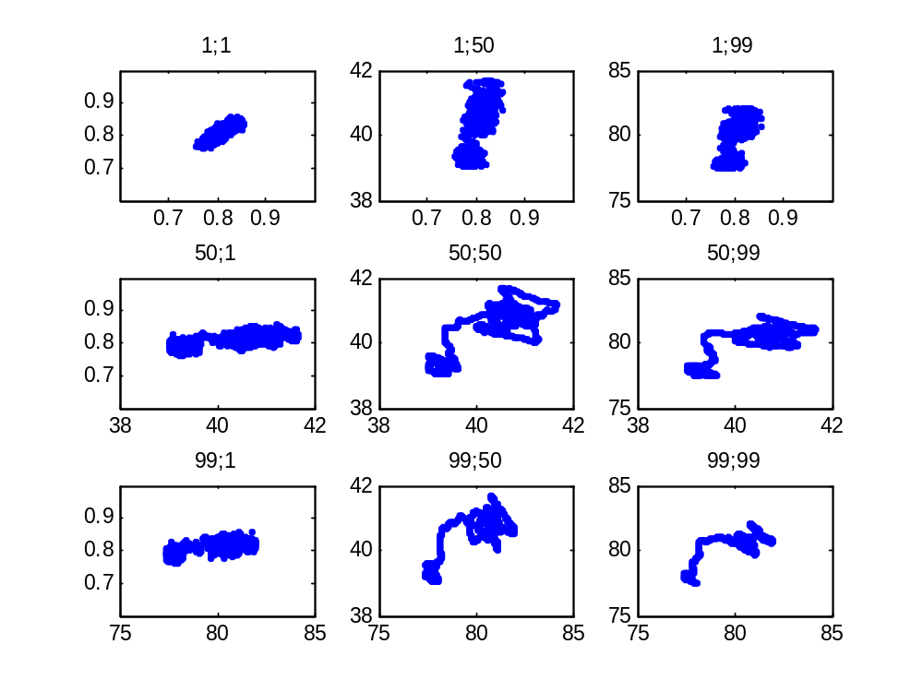

These subplots allow for a step-wise visual tracking of the GPP transformation from a random-like to a smooth graph.

Next, the final order (j = k = 100) GPP scatter gram is displayed.

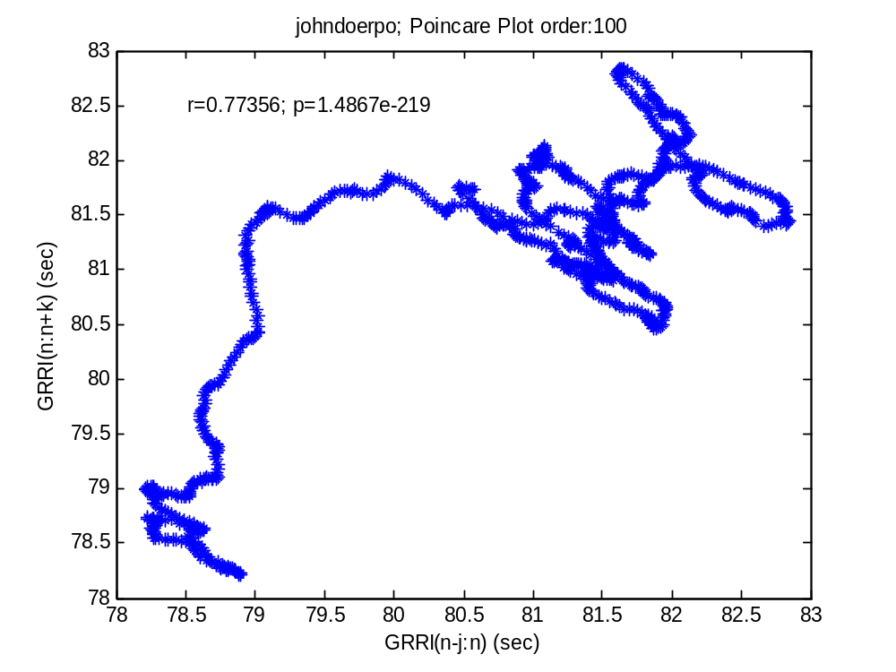

Finally, 3D mesh plot of the Pearson’s matrix is drawn, as well as the corresponding contour map, with crosses in positions of the detected local Pearson’s maxima.

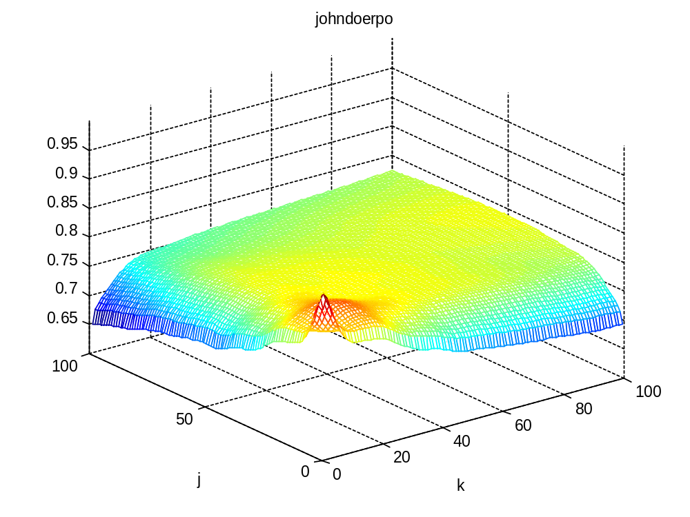
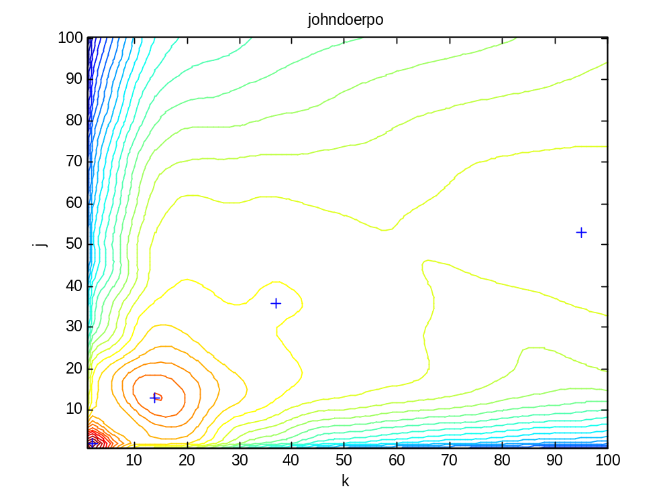
The corresponsding Normalized Asymmetry Index (NAI) is printed, as well as the matrix with Pearson’s local maxima positions in the decreasing order.

NAI =

-0.0058

r max positions

j k r

2.0000 2.0000 0.8803
13.0000 14.0000 0.8283
36.0000 37.0000 0.7914
53.0000 95.0000 0.7879

save the Pearson matrix, local maxima and NAI (y/n):y
file saved:johndoerpormat100.mat

Structure of the output filename:

“Johndoe” – subject code
“rpo” – inherited from the input file, meaning R peak positions
“rmat’ – meaning that matrix contains Pearson’s coefficients
“100” – referring to the maximal analysis order

